SIMATS ENGINEERING
SAVEETHA INSTITUTE OF MEDICAL AND TECHNICAL SCIENCES
CHENNAI – 602105
Department of Computer Science and Engineering

ASSESSMENT TOOL 3 – Visualization Design Activity

Course Code: | DSA0502 | Course Title: | Query Processing for Data Science
CO Assessed: | CO5 | Assessment: | Tool 3– Visualization Design Activity
Weightage: | 35% | Total Marks:
CO5 Statement: Crea te meaningful visualizations using Pandas and Matplotlib, including charts, distributions, relationships, and interactive visual representations for effective communication
Student Name: | G Rajasekhar Reddy | Reg. No.: | 192424216
Section / Batch: | B.Tech-AI&DS | Date of Submission: | 20/08/2026
Faculty In-charge: | Dr. B.Shyamala Gowri | Project Mode: | Individual Submission

Code of Conduct
I G. Rajasekhar Reddy(192424216) (Name / Reg No) certify that this submission is my original work and that I have adhered to all guidelines specified for this assessment. I understand that any violation of academic integrity rules will result in disciplinary action.
Signature: G. Rajasekhar Reddy

1. Basic Plot Creation
Create a line plot using a small dataset of monthly sales. Add title, x-axis label, y-axis label, legend and grid.
Objective: Create a Python program using Matplotlib to display the monthly sales of a company as a line plot. The graph should contain:
- Title
- X-axis label
- Y-axis label
- Legend
- Grid
- Markers for each month's sales
Use the given monthly sales dataset and display the sales trend clearly.
2. Dataset:
UCI Online Retail dataset. It contains 541,909 real transaction records from a UK-based online retailer, covering December 2010 to December 2011. It includes Quantity, InvoiceDate, and UnitPrice, which we can use to calculate monthly sales.

Download Online Retail.xlsx from the UCI repository. The important columns are:
Column | Meaning
InvoiceNo | Invoice/transaction number
StockCode | Product code
Description | Product name
Quantity | Quantity purchased
InvoiceDate | Date and time of transaction
UnitPrice | Price per item
CustomerID | Customer number
Country | Customer country

Formula Used:
The sales amount for each transaction is calculated as:
Sales = Quantity × UnitPrice
Then all transaction sales are grouped month-wise.

3. Python Code:
import pandas as pd
import matplotlib.pyplot as plt

# Load the real dataset
data = pd.read_excel("Online Retail.xlsx")

# Convert InvoiceDate to date format
data["InvoiceDate"] = pd.to_datetime(data["InvoiceDate"])

# Calculate sales for each transaction
data["Sales"] = data["Quantity"] * data["UnitPrice"]

# Group sales month-wise
monthly_sales = data.groupby(
data["InvoiceDate"].dt.to_period("M")
)["Sales"].sum()

# Create line plot
plt.plot(
monthly_sales.index.astype(str),
monthly_sales.values,
marker="o",
label="Monthly Sales"
)

# Add title
plt.title("Monthly Sales - Online Retail Dataset")

# Add axis labels
plt.xlabel("Month")
plt.ylabel("Sales (£)")

# Add legend
plt.legend()

# Add grid
plt.grid(True)

# Rotate month names
plt.xticks(rotation=45)

# Adjust layout
plt.tight_layout()

# Display graph
plt.show()
Output:
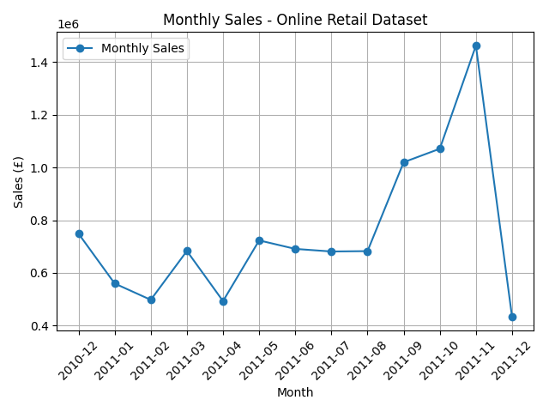

The output is a line graph showing the total sales for each month.
- X-axis: Month
- Y-axis: Total sales in pounds
- Circle markers: Monthly sales values
- Line: Connects the monthly sales values
- Grid: Helps compare values
- Legend: Identifies the sales line
- Title: Describes the visualization
Result:
The monthly sales of the Online Retail dataset were successfully calculated and visualized using a line plot. The graph makes it easy to observe how sales change over time and identify months with higher or lower sales.

8. Counts and Frequencies
Create a categorical dataset such as department-wise employee count. Represent the frequencies using a bar chart.
1. Aim:
To analyze the frequency of retail transactions by country and represent the frequencies using a bar chart.
2. Introduction:
Counts and frequencies are used to find how often each category occurs in a dataset. In this activity, the Online Retail dataset is used. The Country column is a categorical variable. We count the number of records for each country and visualize the most frequent countries using a bar chart.
3. Dataset Used:
The dataset used is Online Retail.xlsx. It contains 541,909 records and 8 columns. The Country column is selected for frequency analysis.
Item | Details
Dataset | Online Retail.xlsx
Categorical variable | Country
Frequency | Number of retail transaction records
Chart type | Bar chart

4. Objective:
- Read the Online Retail Excel dataset using Pandas.
- Count the number of records for each country.
- Select the top 10 countries by frequency.
- Represent the frequencies using a bar chart.
- Interpret the chart and identify the most frequent country.

5. Python Program:
import pandas as pd
import matplotlib.pyplot as plt
df = pd.read_excel("Online Retail.xlsx")
country_counts = df["Country"].dropna().value_counts().head(10)
country_counts.plot(kind="bar")
plt.title("Top 10 Countries by Number of Transactions")
plt.xlabel("Country")
plt.ylabel("Number of Transactions")
plt.xticks(rotation=45)
plt.grid(axis="y")
plt.show()
6. Explanation of the Program:
import pandas as pd – Imports Pandas for reading and analyzing the Excel dataset.
import matplotlib.pyplot as plt – Imports Matplotlib for creating the bar chart.
pd.read_excel("Online Retail.xlsx") – Reads the Excel file and stores the data in a DataFrame.
df["Country"] – Selects the Country column.
value_counts() – Counts how many records belong to each country.
head(10) – Selects the 10 countries with the highest frequencies.
plot(kind="bar") – Creates a bar chart using the frequency values.
plt.title(), plt.xlabel(), plt.ylabel() – Adds the title and axis labels.
plt.grid(axis='y') – Adds horizontal grid lines to make comparison easier.
7. Output – Frequency Bar Chart:
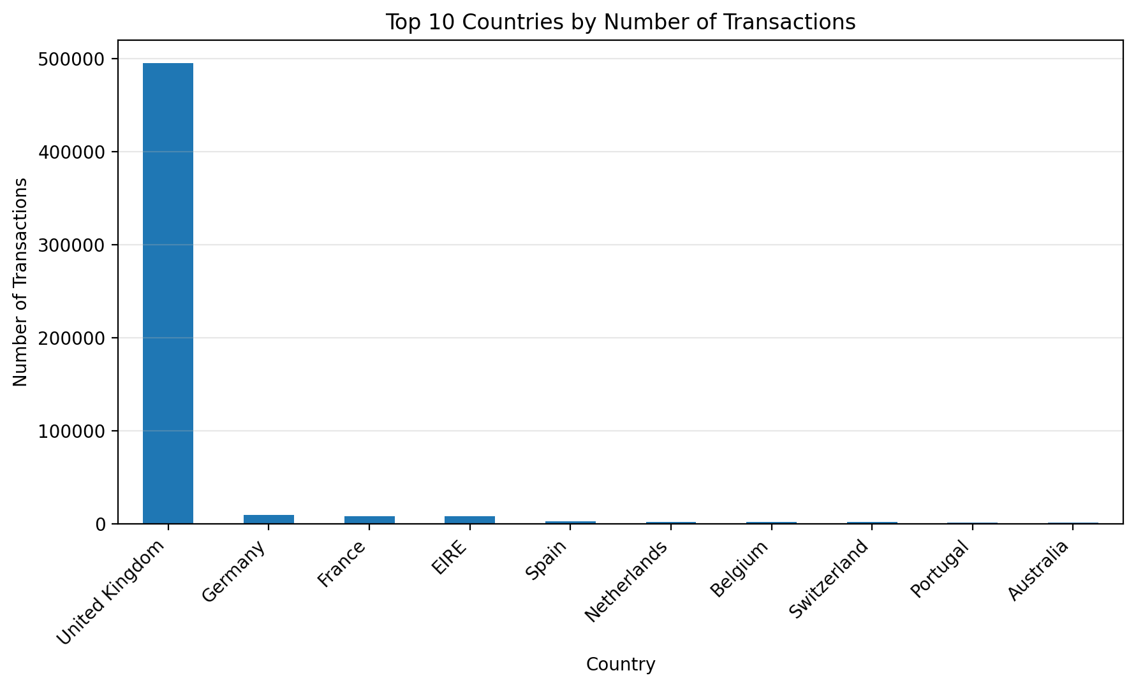
8. Sample Frequency Results:
Rank | Country | Number of Transactions
1 | United Kingdom | 495,478
2 | Germany | 9,495
3 | France | 8,557
4 | EIRE | 8,196
5 | Spain | 2,533
6 | Netherlands | 2,371
7 | Belgium | 2,069
8 | Switzerland | 2,002
9 | Portugal | 1,519
10 | Australia | 1,259

9. Observation:
The bar chart shows the frequency of transactions for the top 10 countries. United Kingdom has the highest number of transaction records among these countries, with 495,478 records. The bar heights make it easy to compare the frequencies between countries.
10. Conclusion:
The Counts and Frequencies activity shows how categorical data can be summarized and visualized. Using Pandas value_counts(), the number of retail records for each country was calculated. A bar chart was then used to clearly compare the frequencies. This makes the distribution of transactions easier to understand than looking at the raw dataset.

